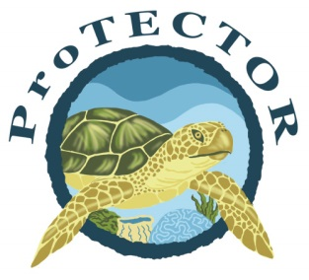
Protective Turtle Ecology Center for Training, Outreach, and Research, Inc.

Honduras Turtle Adoption Program

ProTECTOR is a research project conducted by Loma Linda University’s Marine Biologist,
Dr. Stephen G. Dunbar on the ecology, biology and conservation of endangered sea turtles in the waters of Honduras, Central America (for more information see www.TurtleProTECTOR.org).

To increase awareness and gather conservation and funding support for the ProTECTOR, we have developed the Honduras Turtle Adoption Program that provides an opportunity for you to adopt sea turtles as a part of the ProTECTOR program.

Donor Name: _________________________________ Phone ___________________________
Donor Address: ___________________________________________________________________
Adopter Name(s) to be printed on certificate: Circle Turtle Preference (see below)
1. ______________________________________ Turtle’s Name ____________________ H G O S
2. ______________________________________ Turtle’s Name ____________________ H G O S
3. ______________________________________ Turtle’s Name ____________________ H G O S
Address to mail certificate (if different) __________________________________________________
Email address to send electronic turtle file _______________________________________________
Please place adopter name(s) on ProTECTOR website Do not place name(s) on website
Turtle Adoption Information: Qty Total
Juvenile Hawksbill Sea Turtle (H) _____ X $75 __________
Juvenile Green Sea Turtle (G) _____ X $75 __________
You will receive: an official adoption certificate with the turtle’s flipper tag numbers, an electronic file with photos and your turtle’s information, and your name on the website.
Nesting Olive Ridley Sea Turtle (O) _____ X $150 __________
You will receive: an official adoption certificate with the turtle’s flipper tag numbers, an electronic file with photos and your turtle’s information, your name listed on the adoption website, and information about your nesting turtle
Nesting Turtle and Nest (NN) ______ X $500 __________
You will receive: an official adoption certificate with the turtle’s flipper tag numbers, an electronic file with photos and your turtle’s information, your name listed on the adoption website, nest and egg information for your nesting turtle, and up to four (4) t-shirts.
Satellite Tagged Nesting Olive Ridley Sea Turtle (S) _____ X $3000 __________
You will receive: an official adoption certificate with the turtle’s flipper tag numbers, an electronic file with photos and your turtle’s information, your name listed on the adoption website, updates and maps of your turtle’s travels, and up to four (4) t-shirts.
T-shirt sizes & quantities: ____ S ____M ____ L ____ XL ____XXL
I would like a tax receipt. Amount Enclosed: $____________
Please send this form with your check or money order to: Adoption Date _____/_____/____
Dr. Stephen G. Dunbar, ProTECTOR (mm / dd / yyyy)
c/o Dept. of Earth & Biological Sciences
Loma Linda University, Loma Linda, CA 92350

